Prof. P Rheeder
School of Medicine
Faculty of Health Sciences
University of Pretoria
Room 92436
Department of Internal Medicine
Steve Biko Academic Hospital
Bophelo Road
Tel: 012 354 3861
Fax: 086 607 1891
prheeder@medic.up.ac.za

18/03/2016
The Editor
South African Family Practice.

Re: Diabetes and Hypertension screening in Zandspruit, Johannesburg 2012-2014.
Dear Editor
On behalf of University of Pretoria and Project HOPE South Africa we would like to present our results on screening for hypertension and diabetes in Zandspruit, Johannesburg for review and possible publication.
The burden of non-communicable diseases (NCD) is currently of significant interest locally and internationally. The Department of Health is currently embarking on a large screening campaign and our results add knowledge to the debate concerning screening for these conditions as well as providing estimates of prevalence in this community.
The screening evaluation was undertaken as one of the activities of Project HOPE to address the burden of NCD in the informal settlement of Zandspruit. The activities of Project HOPE and University of Pretoria are funded by the Lilly NCD partnership.
Yours Sincerely

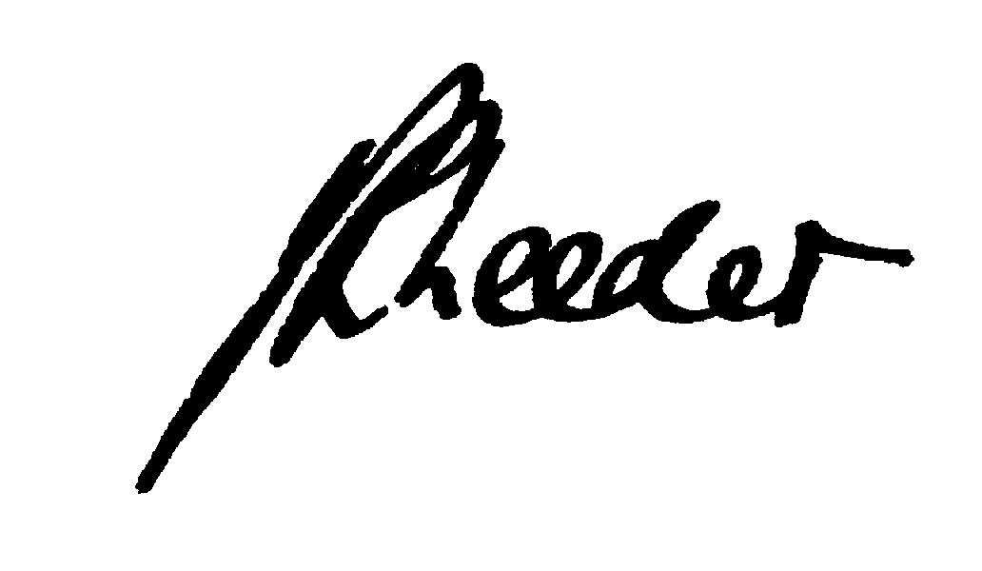
Specialist Physician
Steve Biko Academic Hospital

