Private Bag X6001, Potchefstroom
South Africa 2520
Tel: 018 299-1111/2222
Web: http://www.nwu.ac.za

Professor Ogunbanjo
The Editor-in-chief
South African Family Practice
P.O. Box 14804
Lyttelton, 0140
15 October 2014
Dear Prof Ogunbanjo
Antibiotic Use in Namibia: Prescriber Practices for Common Community Infections
I would be grateful if you would consider the attached paper (original article) for publication in the South African Family Practice. I confirm that all authors have contributed in the conception, design, data collection and analysis as well as the drafting and review of the article. I further confirm that the full and final manuscript has been perused and approved for submission by all three authors. I further confirm that no part of this paper has been published or considered for publication elsewhere.

Antibiotic usage globally is high and is influenced by prescriber practices. However, no study has been done in Namibia to understand prescriber practices. The study uncovered that the antibiotic prescribing practices in Namibia are not in line with the national treatment guidelines and local sensitivity patterns; indicating the need for dissemination and training on both guidelines and local data and implementing strategies to enforce adherence to guidelines.
There was no funding for this study.
Attached with this letter is the abstract (244 words) and the manuscript (3000 words).
The study is authored by:
- Mrs Dawn D Pereko - PhD student, North-West University dineopereko@gmail.com, P.O. Box 35209, Kleine Kuppe, Windhoek, Namibia; +264 81 293 4754 (corresponding author).
- Prof Martie S. Lubbe - Medicine Usage in South Africa, Faculty of Health Sciences, School of Pharmacy, North-West University, Potchefstroom, South Africa
- Prof Sabiha Y. Essack - School of Health Sciences, University of KwaZulu-Natal, Durban, South Africa. Prof Essack is a member Global Respiratory Infection Partnership (GRIP) sponsored by Reckitt and Benckiser.

The authors suggest the following as reviewers:
Dr Mehdi Rajabi: mehdirj@aol.co.uk
Stephen Byrne: byrne@ucc.ie
Asa Auta : asaauta@yahoo.com

Yours sincerely,
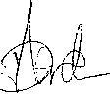
Dineo Dawn Pereko
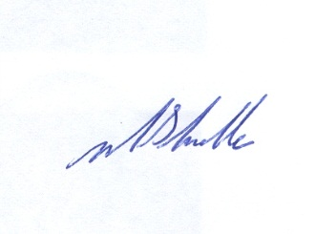
Martie Lubbe

