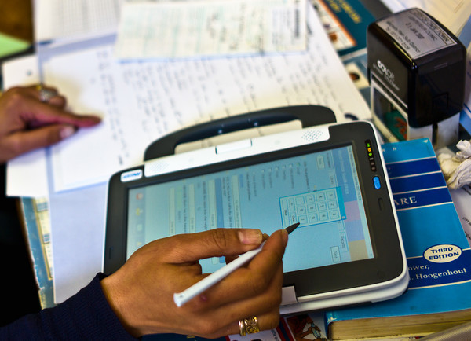
Figure 1: Nurse using the convertible classmate personalised computer tablet with stylus

