Figure 1A and 1B: Complete rectal excision with intact mesorectum
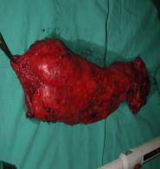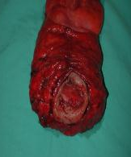

Figure 2: Intact pelvic sympathetic nerves after rectal excision.
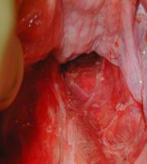

Figure 3: abdominal view of a mid-rectal staple line.
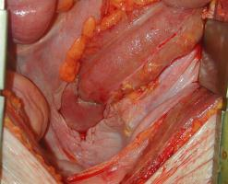
Figure 4: Endoscopic view of healed stapled rectal anastomosis
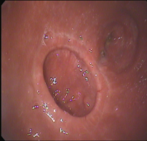

Figure 5: Image generated by ERUS, demonstrating a large non-invasive adenoma
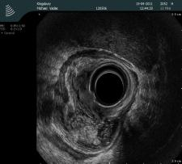

Figure 6: Operative image of resection
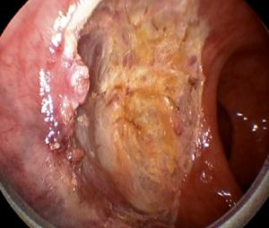

Figure 7: Fractured, disorientated specimen after difficult transanal local excision
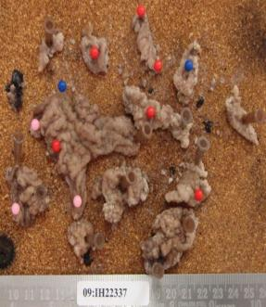
Figure 8: Abdominal X-ray of a decompressed bowel after stent placement
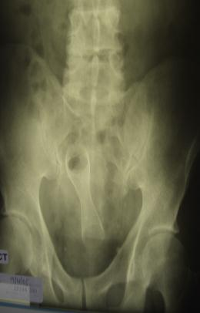

Figure 9: Resected specimen containing a stent, used as a "bridge to surgery"

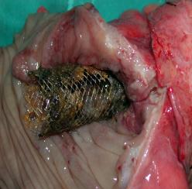

Figure 10: Specimen delivery through a suprapubic incision after laparoscopic total colectomy for megacolon
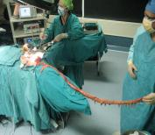

Figure 11: Handsewn ileo-rectal anastomosis

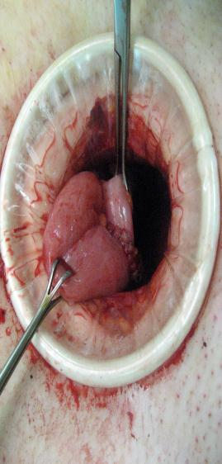

Figure 12: The post-operative abdomen

