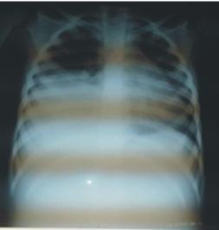
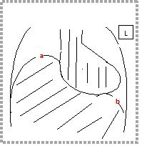
B
A
Figure 1A: Chest radiograph showing homogenous opacity in the right hemithorax, a clear right costo-phrenic angle and absence of meniscus sign. 1B: A sketch of figure 1A highlighting the elevated right hemidiaphragm ‘a’, normal left hemidiaphragm ‘b’, clear costophrenic angles and mediastinal shift to the left.
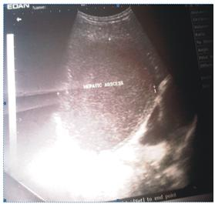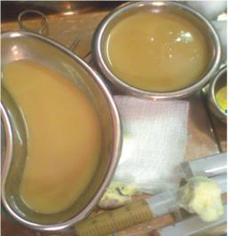

Figure 2: Showing a well-defined, rounded area of mixed echogenicity measuring 13.4 x 9.03cm in the posterio-superior aspect of the right lobe, in keeping with a liver abscess. Figure 3: Purulent aspirate (280mL) obtained from the liver abscess via ultrasound-guided percutaneous drainage.

