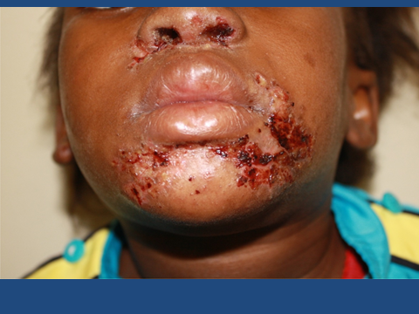
Fig 1. Impetigo contagiosa in a child
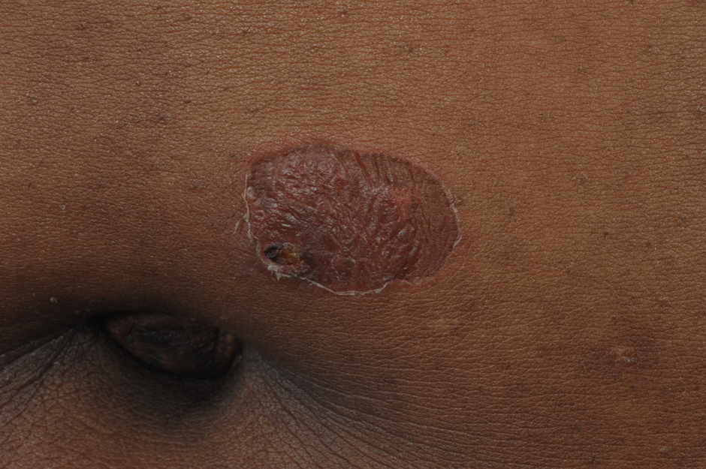
Fig 2. Bullous impetigo. Note the “collarette” scale at the periphery of the lesion
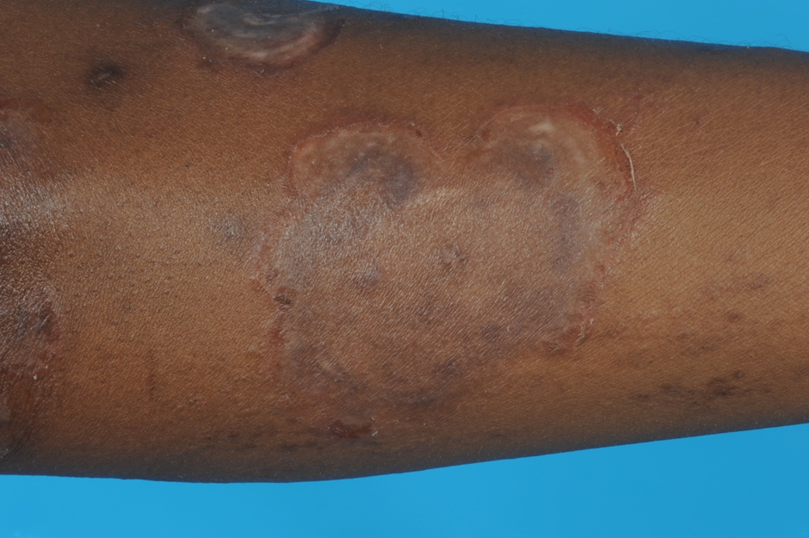
Fig 3. Bullous impetigo. Note the polycyclic pattern
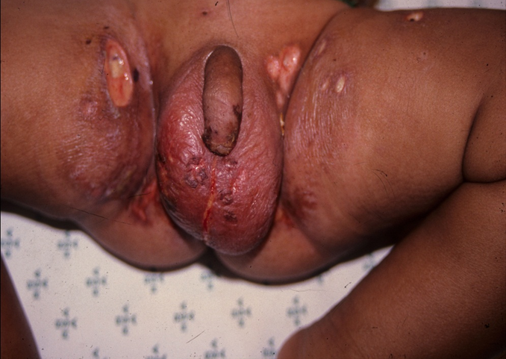
Fig 4. Ecthyma in a child. Note the purulent irregular ulcers
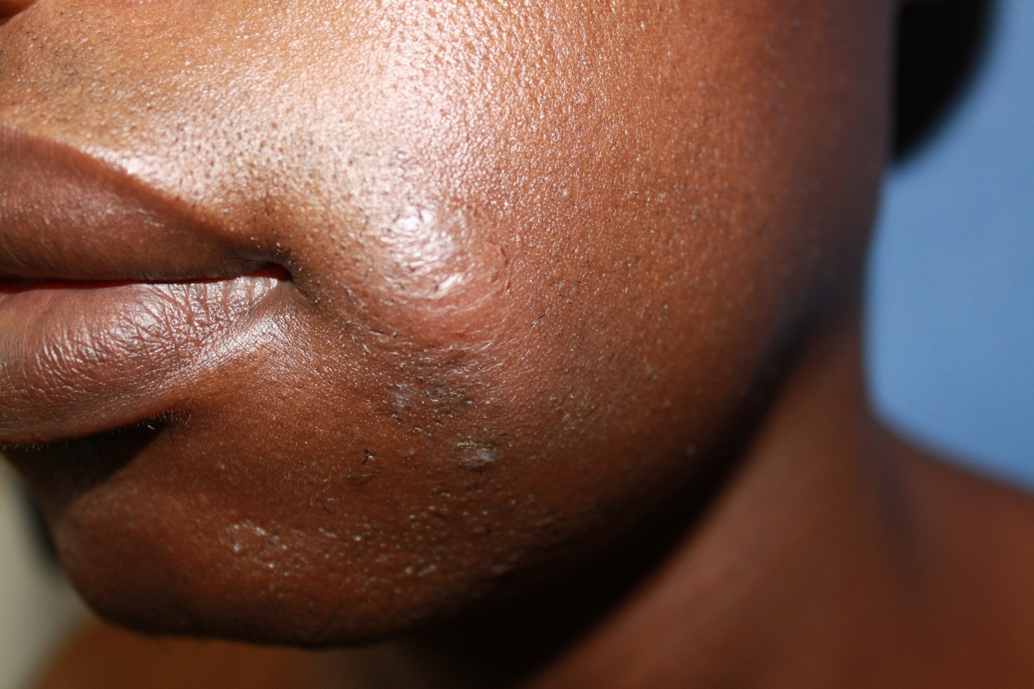
Fig 5. Cellulitis on the cheek. The portal of entry is a small traumatic injury at the tip of the arrow

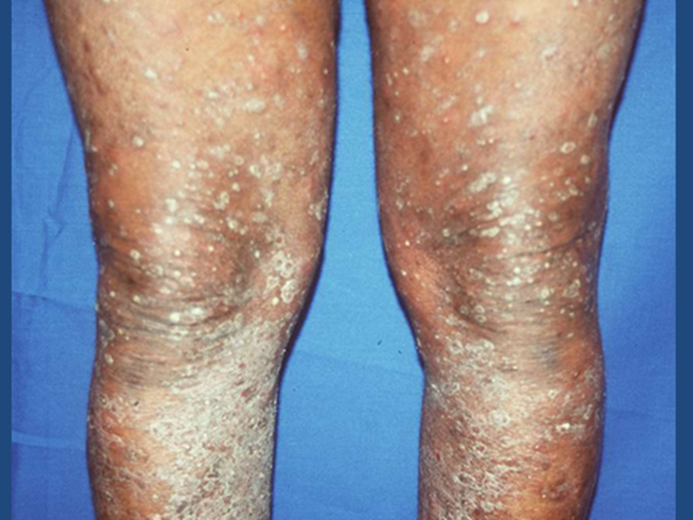
Fig 6. Furunculosis in an elderly diabetic patient

