Glaucoma: What should the general practitioner know?
Appendix 1
List of photographs
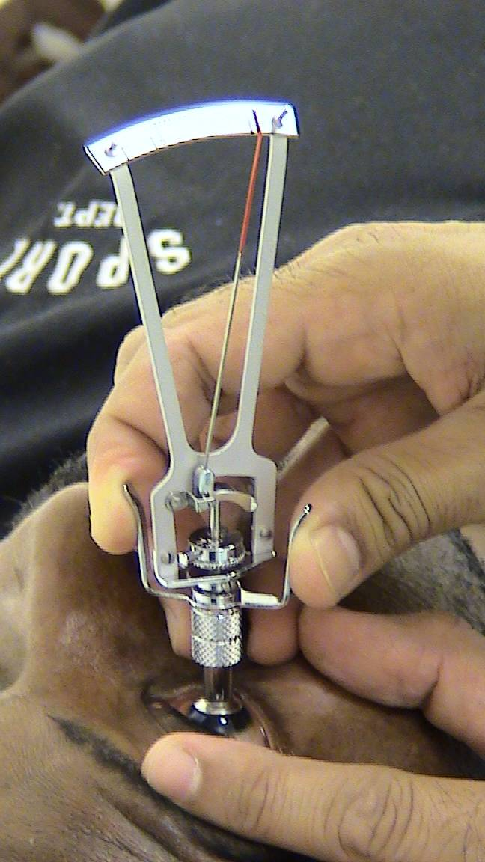
Figure 1 Schiotz Tonometer

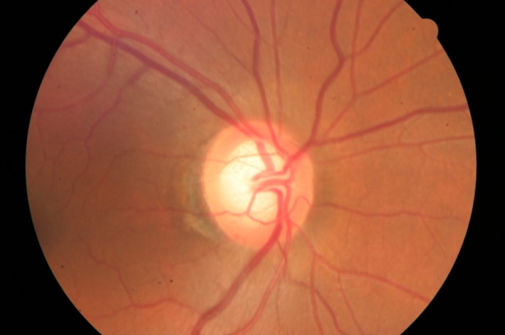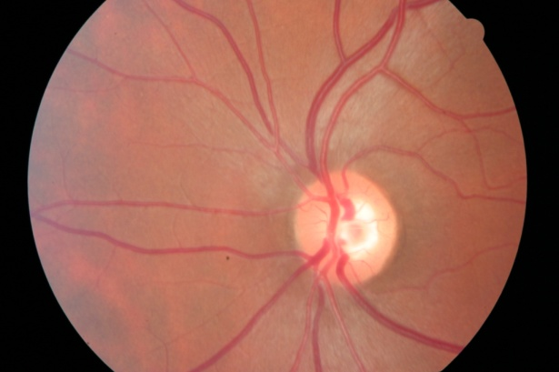
Figure 2 Glaucomatous optic discs

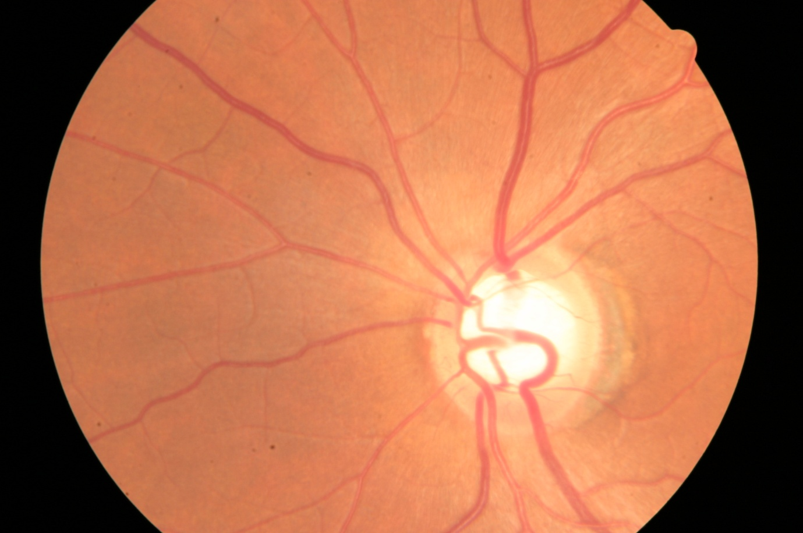
Features of glaucomatous disc
Bayonetting of blood vessel
Cup to disc ratio of more than 0,4
Pale disc with nasally displaced blood vessels
Thin rim that does not comply with the ISNT rule
Peripapillary choroidal atrophy

Figure 3 Features of a glaucomatous disc

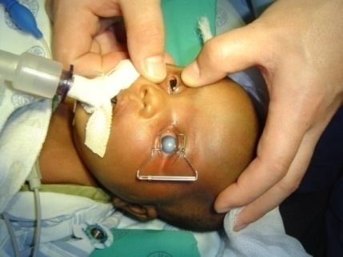
Figure 4 Congenital glaucoma in the left eye of a baby with Sturge-Weber syndrome

Appendix 2
List of Tables
Table I Classification of Glaucoma¹⁰
Primary Open Angle Glaucoma (POAG)
Normal Tension Glaucoma (NTG)
Ocular Hypertension (OHT)
Primary Angle Closure Glaucoma (PACG)
Secondary Glaucoma
Congenital glaucoma

Table II Risk factors for developing POAG
General
Increasing age (the prevalence of glaucoma for persons <40 years = rare; 40-60 years = 1%; 60-80 years 2%; >80years = 4%) ¹²
African-Caribbean origin (5x higher than Caucasians)^{1,12,13}
Genetic make-up (first degree relatives of patients 10%)^{1,12,13}
Diabetes mellitus ^{1,12,13}
Myopia ^{1,12,13}
Obesity ¹²
Vascular factors ( migraine; vaso-spastic disease; Raynaud’s disease; hypotension and hypertension) ¹²
Ocular
Level of IOP^{1,12,13} (Higher baseline IOP)
Pseudoexfoliative syndrome^{12,13}
Optic disc features. Cup: disc ratio of more than 0.4, narrowing of neuroretinal rim, disc haemorrhages
Thin corneas ^{12,13}
Retinal disease (retinal vein occlusion 5%; rhegmatogenous retinal detachment, 3% and retinitis pigmentosa) ¹³

Table III Practical tips when screening for glaucoma
- Optic disc examination with an ophthalmoscope is particularly useful when screening for glaucoma in a family practice.
- IOP of higher than 21mmHg with Schiotz tonometer should be referred to an ophthalmologist to evaluate the patient and confirm the diagnosis and initiate treatment.
- When performing routine medical examinations (e.g. ECG, PAP smears, cholesterol) on persons older than 40 years, do a fundoscopy to check for glaucomatous changes of the optic disc and measure the IOP and do visual acuity with a pinhole, to screen for glaucoma.

Table IV Groups at risk of developing acute ACG
- Hypermetropic patients^{12, 19}
- Woman (3-4 times higher)^{12, 19}
- Eskimos (40 times the rate) and Asians have a higher incidence than Caucasians.^{12, 19}
- People of mixed race in Western Cape region, South Africa (Southeast Asian ancestry) 2.3% prevalence ¹⁶
- Black patients have a low risk for developing ACG^{2,12,19}
- Highest incidence between 55-65 years of age ¹²

Appendix 3
SAGS algorithm for glaucoma treatment

