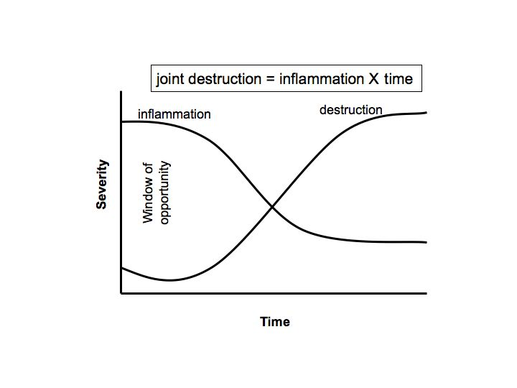
Figure 1. Relationship of joint inflammation and destruction in rheumatoid arthritis

