Ilze,

Please include the following information in the galley for this book review:

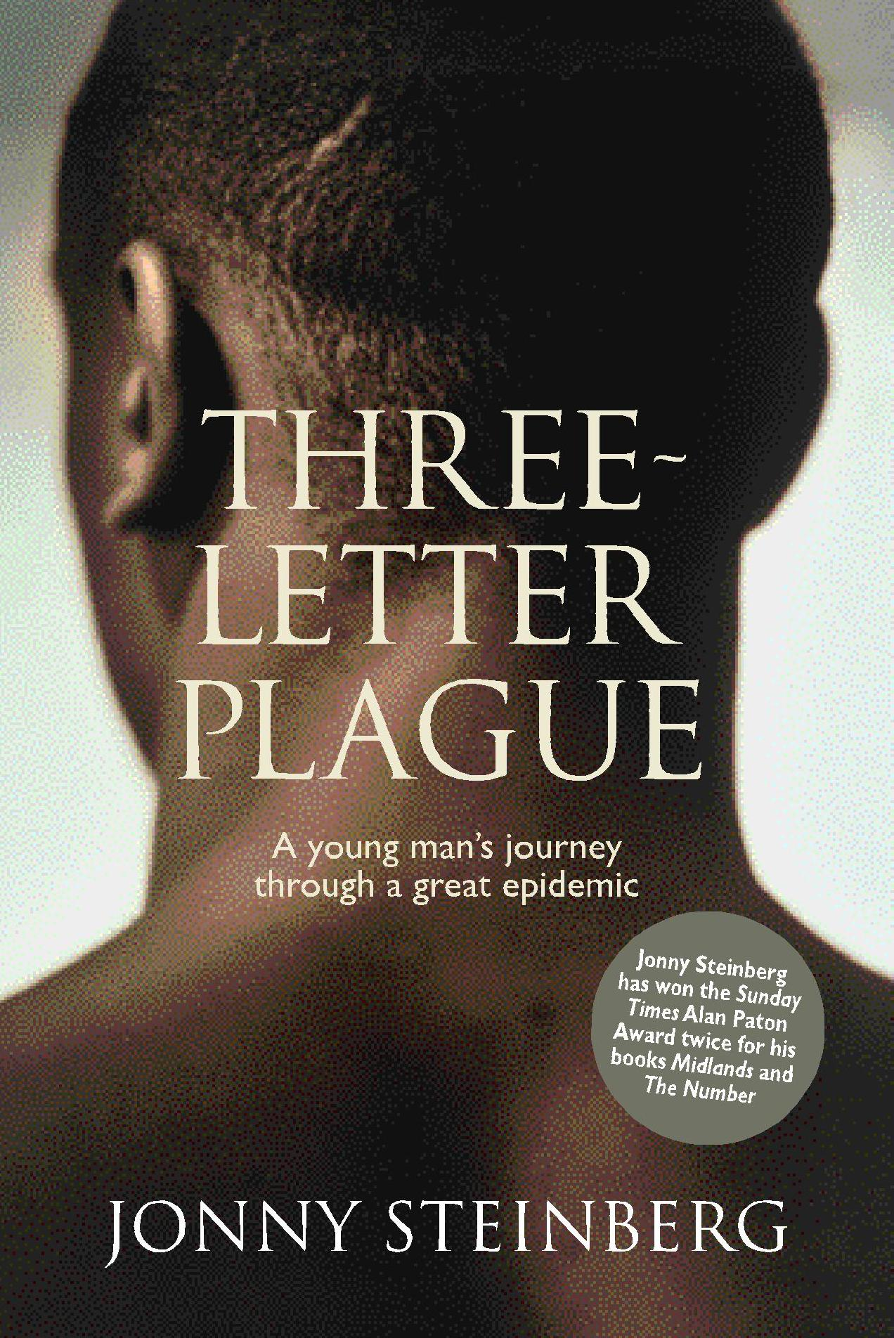
Three Letter Plague: A young man’s journey through a great epidemic
By Johnny Steinberg
Published by Jonathan Ball Publishers, Johannesburg, in 2008
ISBN: 978-1-86842-288-3
Book price: R170

