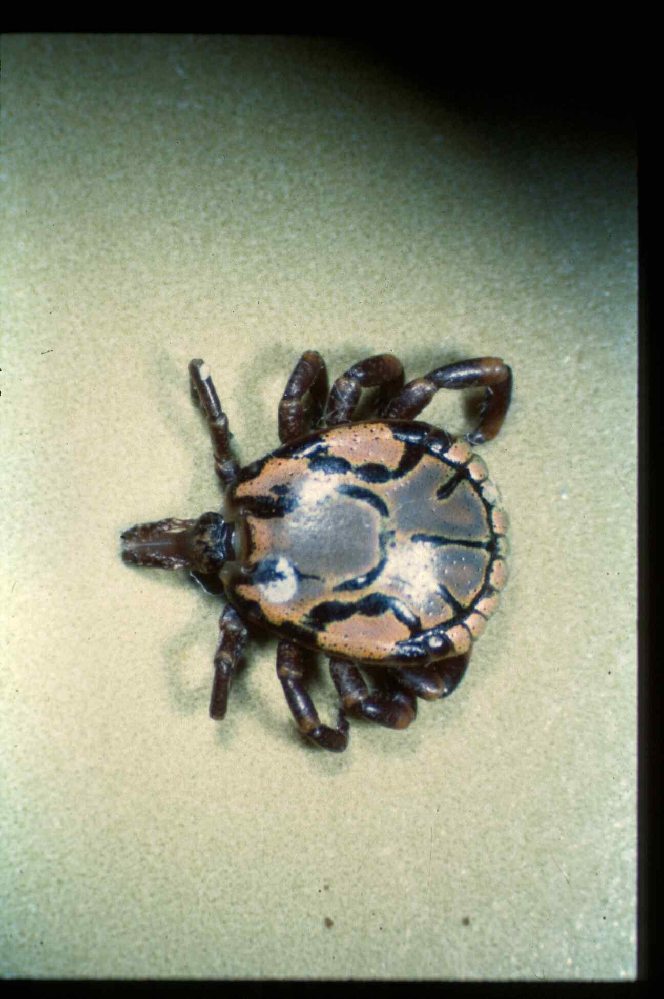

Fig 1: Ambyomma hebreum, adult male (Photo: Drs. P Jupp, A Kemp)

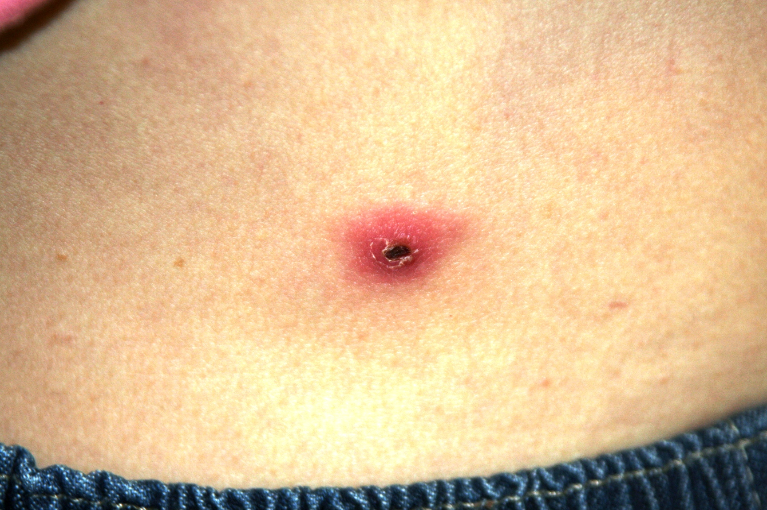

Fig 2: Tick bite fever eschar (Photo: Dr. J Hyslop)

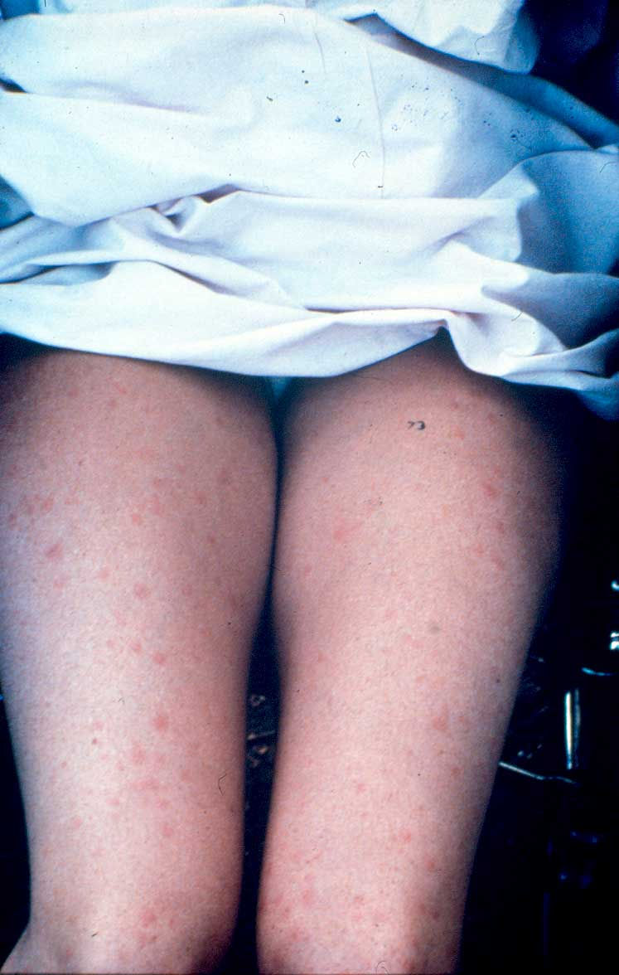

Fig 3: Typical coarse maculopapular rash of tick bite fever (Photo: Dr B Miller)

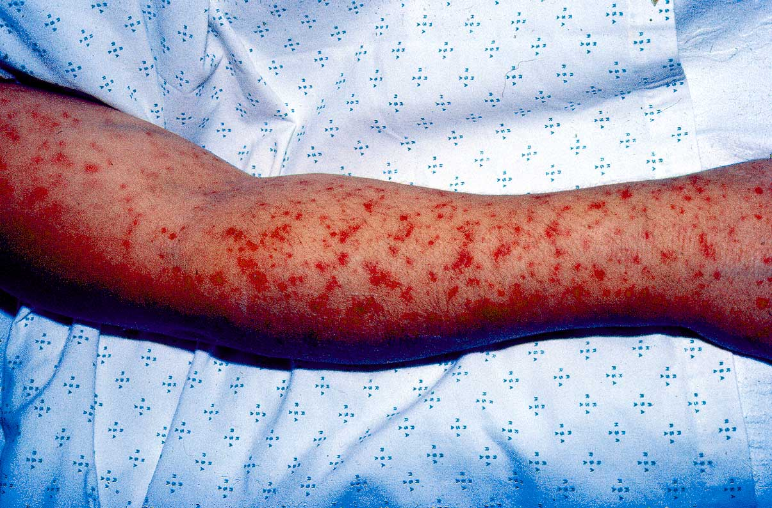

Fig 4: Purpuric rash in severe tick bite fever (Photo: Dr. B Miller)

